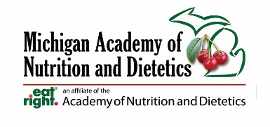

Mayor xxxx
Address
City, Michigan Zip Code

Date

Dear Mayor xxx,
March is National Nutrition Month and Wednesday, March 13 is Registered Dietitian Nutritionist Day. These designations are an excellent opportunity for our city of (fill in the blank) to remind our community that nutritious eating habits are key to maintaining good health, productivity at work and school and a life well lived.
The Academy of Nutrition and Dietetics has chosen this year’s theme as “Beyond the Table.” The campaign addresses the farm-to-fork aspect of nutrition, from food production and distribution to navigating grocery stores and farmers markets — and even home food safety and storage practices. It also describes the various ways we eat — not only around a dinner table but also on the go, in schools and restaurants, at games and events. This theme also includes sustainability, for instance, decreasing food waste from school and work to home and beyond. The Michigan Academy of Nutrition and Dietetics will be actively promoting a shift towards healthier eating styles throughout March with positive nutrition messages and activities.
There are more than 6,000 Registered Dietitian Nutritionists (RDNs) in the state of Michigan. They work in hospitals helping patients maximize their response to medical therapy, in manufacturing helping to enhance the nutritional density of food, and in our schools teaching children about how to pack a healthy lunch and after-school snack. RDNs work in clinics assisting individuals in their efforts to successfully lose weight, navigate food allergies, and maximize athletic performance. They work in our communities to support farmers' markets, food banks, and WIC. They also work in the media helping to provide viewers with sound, easy-to-follow nutrition advice.
The Michigan Academy of Nutrition and Dietetics (You can also insert your local district association here if applicable) would be honored if you would sponsor official proclamations recognizing March as National Nutrition Month and specifically March 13 as Registered Dietitian Nutritionist Day. Your proclamations would lend official recognition to the important work of educating the public on reliable, science-based nutrition information.
If you, or your staff, have any questions concerning the request, please contact me at (insert your phone number and email). I will follow up with your office on this request in the next few days. As always, we appreciate all your efforts to make Michigan a healthier place to work, learn, and live. Thank you for consideration of this special request.
Sincerely, (Your name and contact information)

